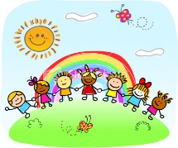
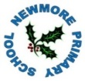
Our Curriculum at
Newmore Primary School
The Wellbeing Indicators (SHANARRI)
Getting It Right For Every Child ((GIRFEC)

Partnerships
CURRICULUM

Rural location, isolated but included
- Promotes and celebrates individuality
- Supports each child to reach their potential
- 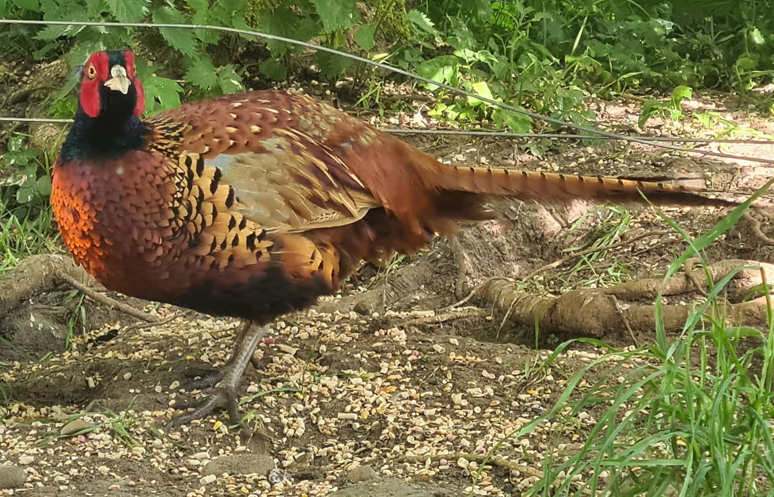

Learn today for a brighter tomorrow
and be your best self.


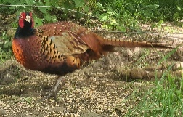
- John Muir
- Minister Visits
- ICT FC
- Active Schools Co-ordinator
- Highlife Highland
- ASG schools
- Families



Philip the Pheasant (& family!)
CULTURAL
A focus on families

- Local Farming
- Tomich Restaurant
- Eco housing developments
- Oil Industry and Renewable Energy – Port Authority
- Tourism
Raising Attainment
Skills
Pupil Voice
Values


- Pupil Council
- Leadership Opportunities
- JRSO
- Rights Respecting School Awards
- Playground Buddies
- Digital Leaders
- Focus Groups
Communication Skills
Resilience
Creativity & Enterprise
Leadership
Compassion
Employability

Never Give Up
Empathy
Working Hard
Motivated
Opportunities
Ready to Learn
Encouraging


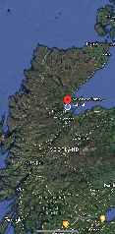
Newmore
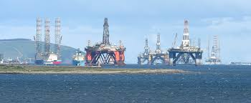
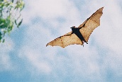
Inverness
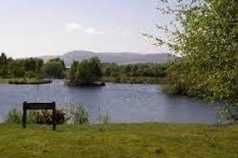

Scotland

